RESULT

The first analysis that we will do is a comparison between the liner method and the Bertamio et Al.

To do this comparison we use this image:

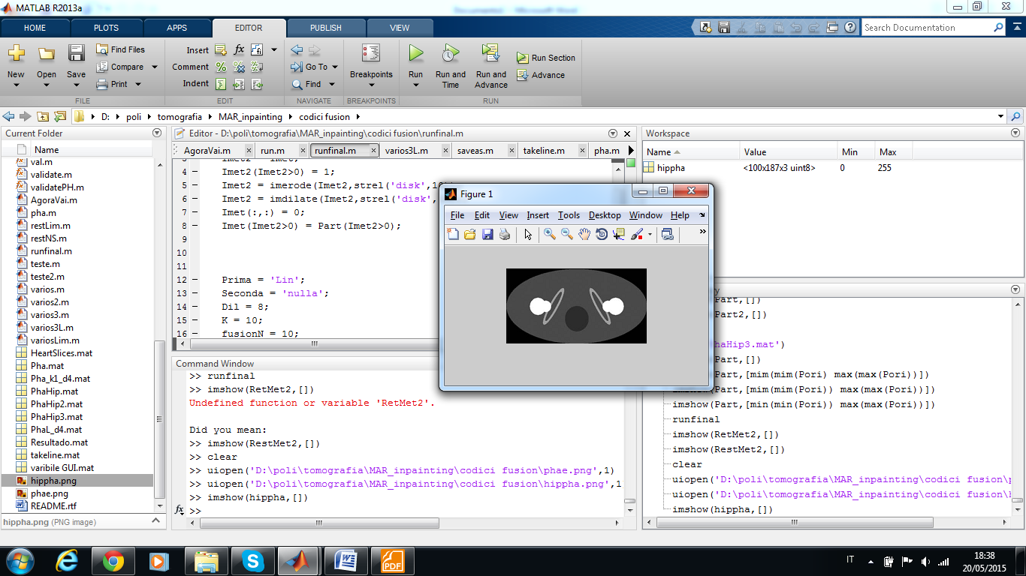

The image represent a hip phantom with bilateral prostheses. However, this is the real image, when we do the tomography the metallic prostheses hinder the process, so the restored image is different. So we need to generate it.

To generate the corrupted image we interpret this image such as the tomography machine. So the first step is to swap the intensity of a pixel by the value that represent the electrical density. The next step is to do the radon transform of the "electrical density image" and them to select the points(pixel) with the intensity is greater than a determined value and replace these values to the threshold. This operation is done because the machine isn't able to measure the x-ray's intensity when there is a high absorption. So it interpret these measure that is meaningless as the maximum absorption that the machine is able to recognize.

On the last step we do the filtered back projection to obtain the corrupted image which we apply a median filter. The figure () illustrate the process.

5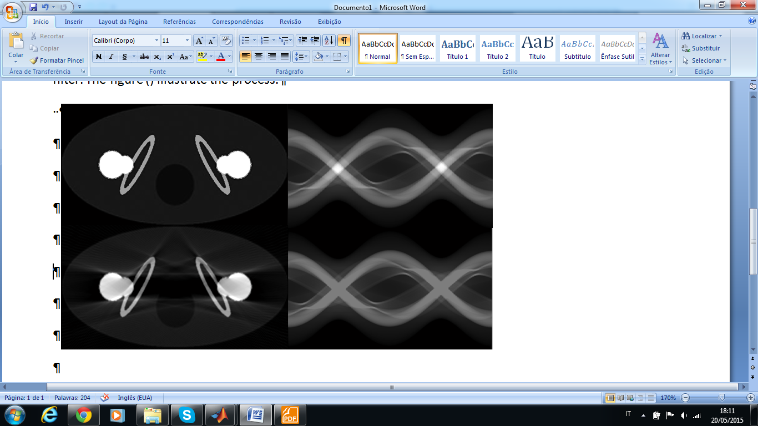

The comparison is realized in quantitative and qualitative way. The qualitative part is based on the visual analyses of the image and its radon transform.

The quantitative is composed by five index that determine how much similar is two images in addition to the analisys of the intensity of the pixel along a line in the figure.

The index used are:

PSNR: Peak-Signal-to-Noise Ratio, (Formula)

NCC: Normalized Correlation Coecient (Formula)

MSSIM: Mean Structure Similarity Index (Formula)

MSE

FSIM

These five index, are calculated in 3 different regions which can be seen in the figure ();

While, the line used to compare the intensity can be seen in the figure ();

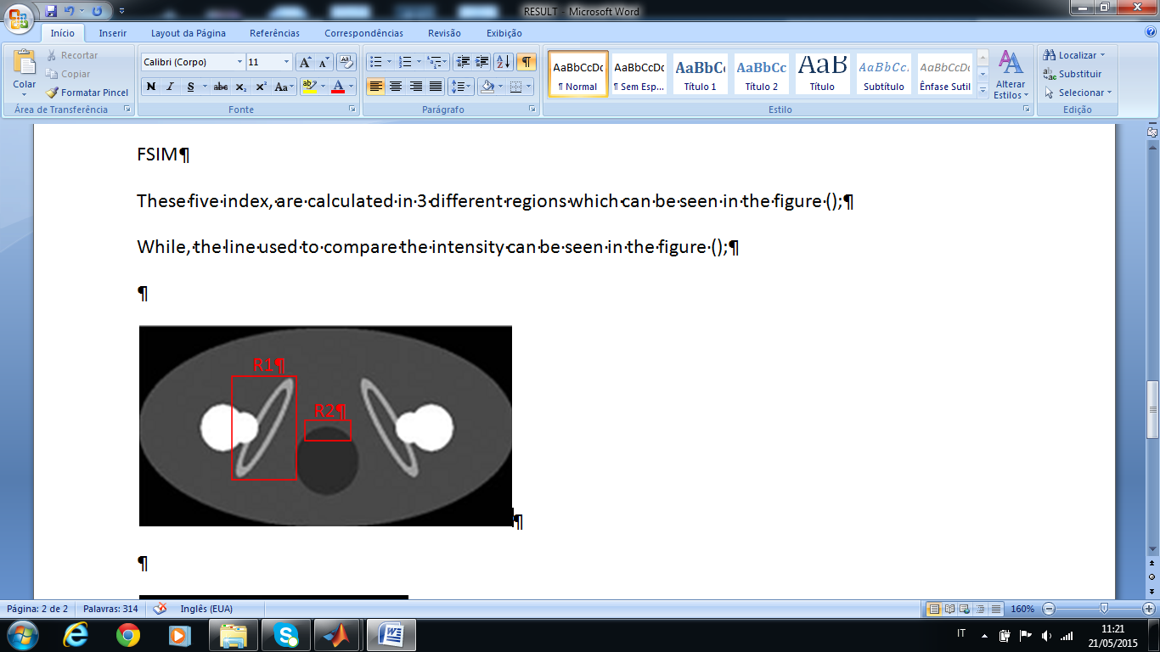



Initially we well do a analysis of the method of bertamio at el and how it change with the tuning parameters K and the dilation of the inpainting domain:

**Bertalmio at el**

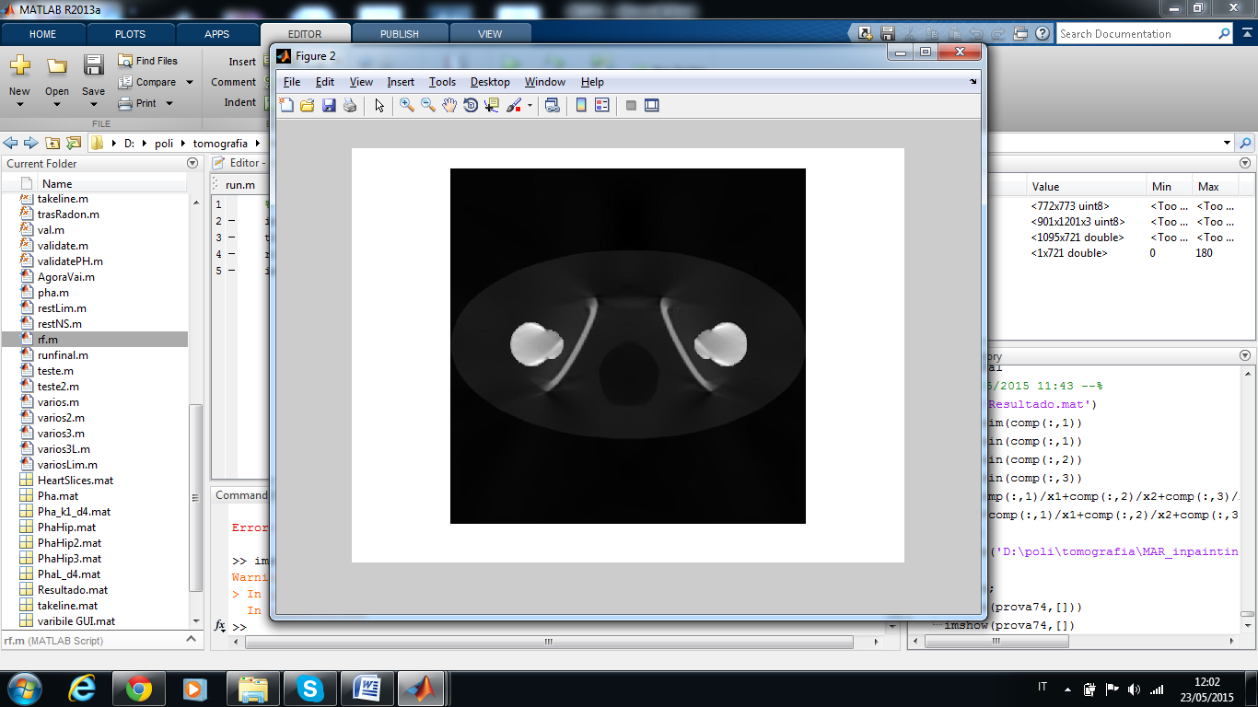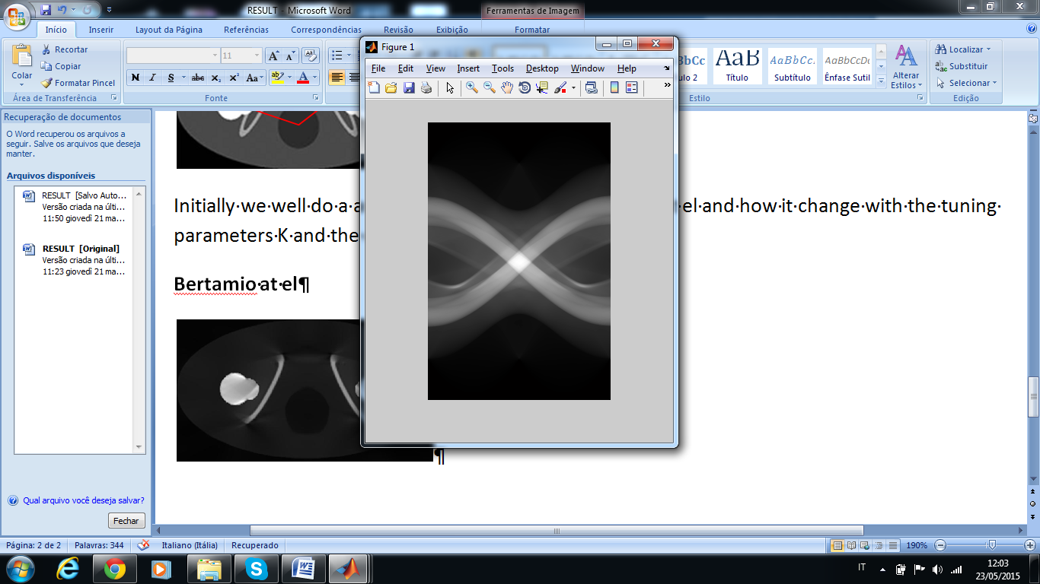

Parameters dil 8 , K = 10

|  |  |  |  |  |  |  |  |  |  |  |
| --- | --- | --- | --- | --- | --- | --- | --- | --- | --- | --- |
|  | Region 1 | | | | | Region 2 | | | | |
|  | MSE | PSNR | CC | mssim | fsim | MSE | PSNR | CC | mssim | fsim |
| Artefato | 4.262 | 17.567 | 0.920 | 0.338 | 0.974 | 1.121 | 3.349 | 0.159 | 0.000 | 0.936 |
| Bertalmio | 6.360 | 15.828 | 0.882 | 0.400 | 0.936 | 0.024 | 20.020 | 0.959 | 0.574 | 0.981 |

The method of Bertamio is capable to retrieve the information in the middle of the image, represented by the region two, but appear a new artifact on the region one. In the graph is easy to see that the method of Bertalmio ignore the existence of the bone nearest of the metal. However, it 'fix' the problem that appered between the two implants, in the artifact image we negative values on this region, while on the Bertalmio image the intensity is almost equal.

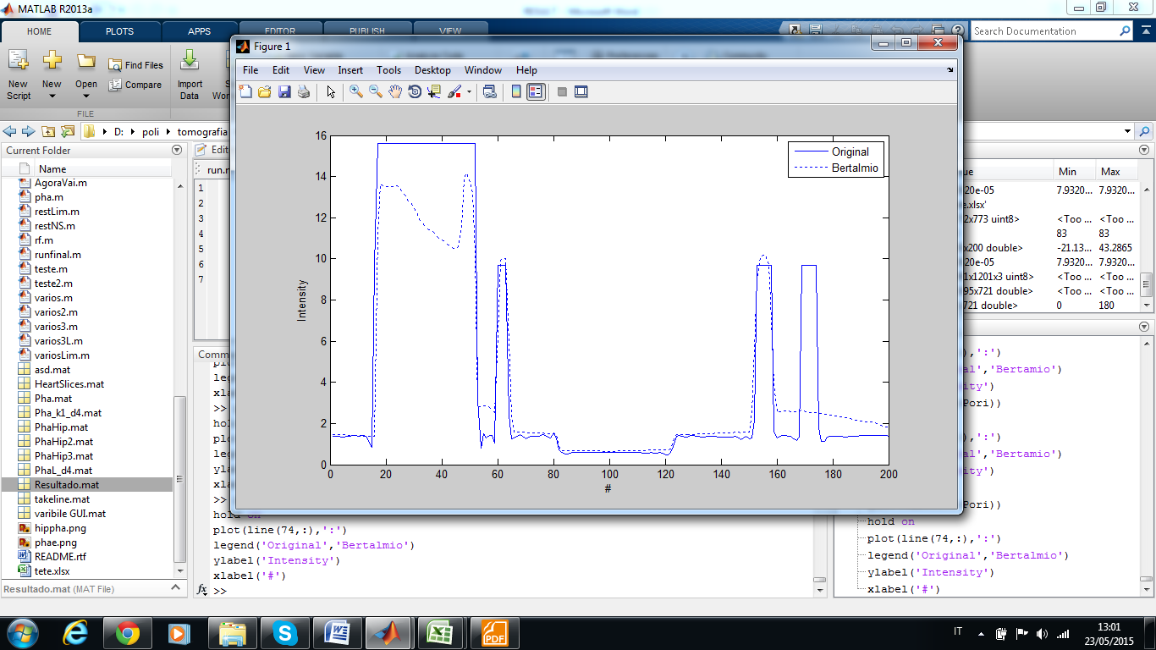 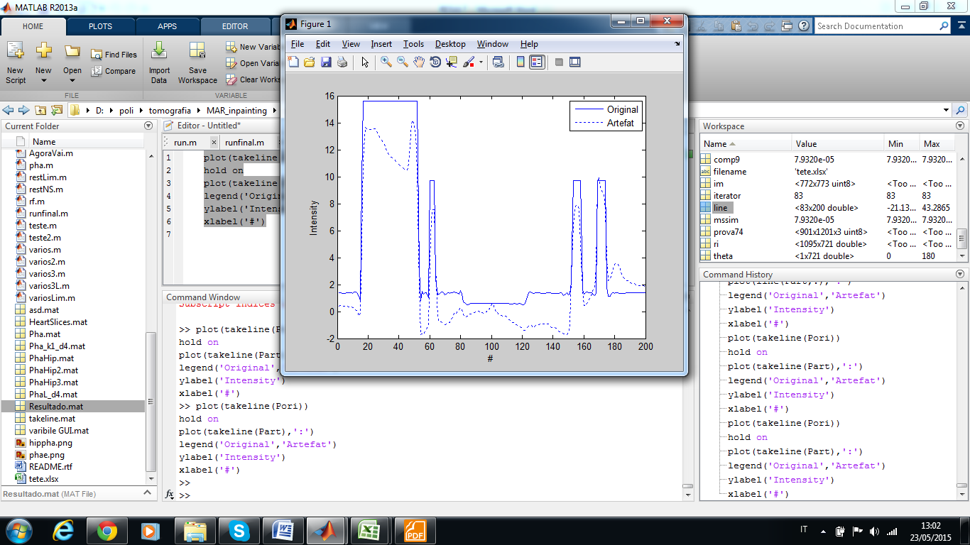

**Parameter Dil**.

The parameter Dil is difficult to tunning, this happens because each image need a different one and it don't have a well defined tendency. The way that we use to chose this parameters is trial and error, obvious this method is very inefficient due to the high execution time of each try.

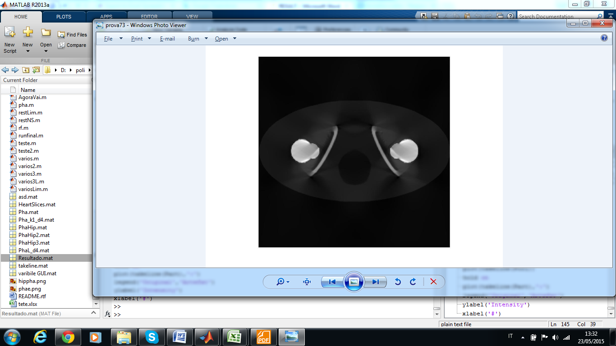 4

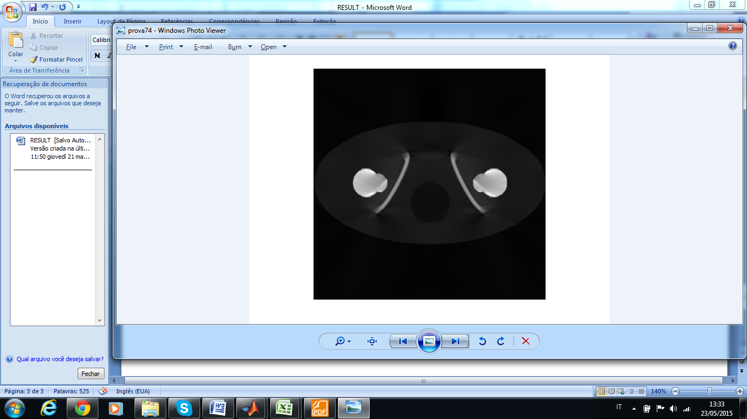 8

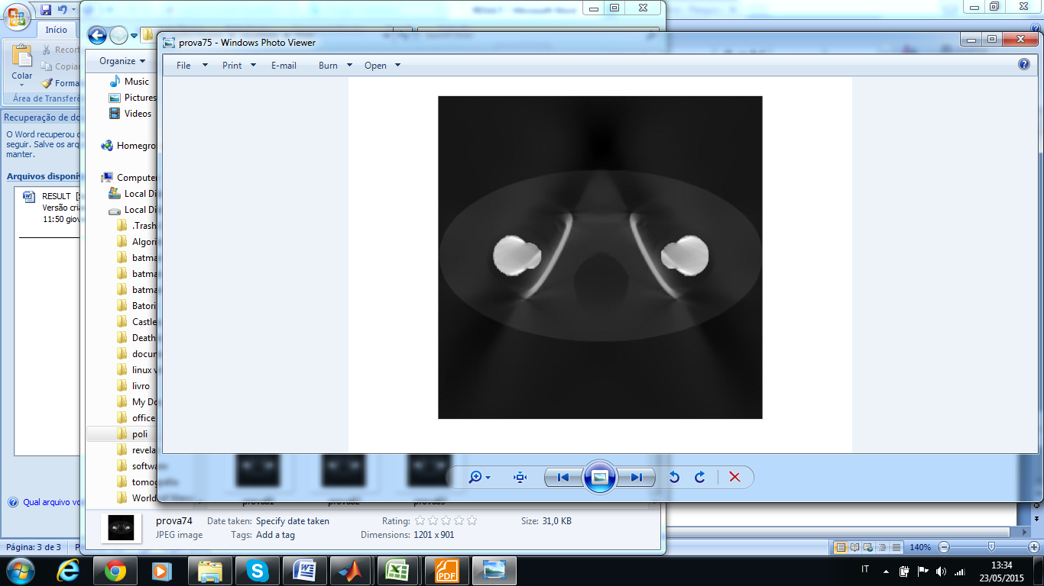 12

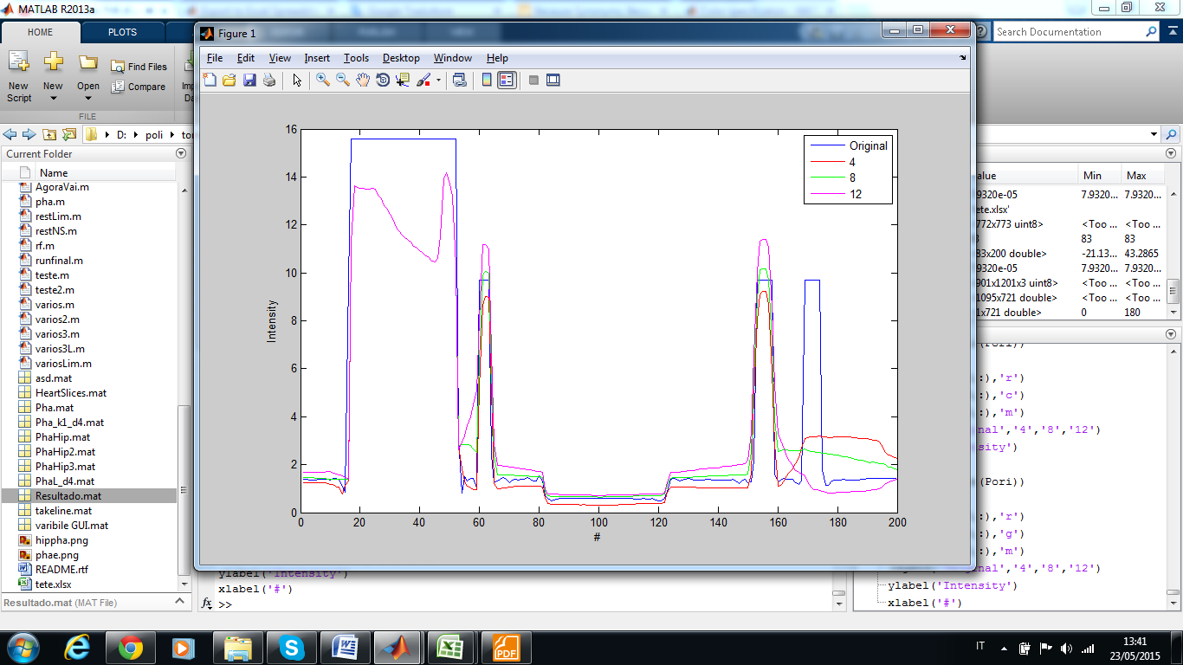

The graph ( ) show the reason for the difficult to set the parameter, if the parameters is smaller or greater than a optimal is not possible judge if a better solution is reach incresing or decresing it. The general rule is take the smallest one in such way majority part of the artifact are surrounded.

**Parameter K**

The parameter of stabilization K has a important role of guarantee the convergence. Despite, in theory, a larger parameter K increase the error, it don't happens in this case since the **blur edge filter** make up the error. Furthermore, K interferes direct on the time of convergence of the method, as shown on the graph (numero)

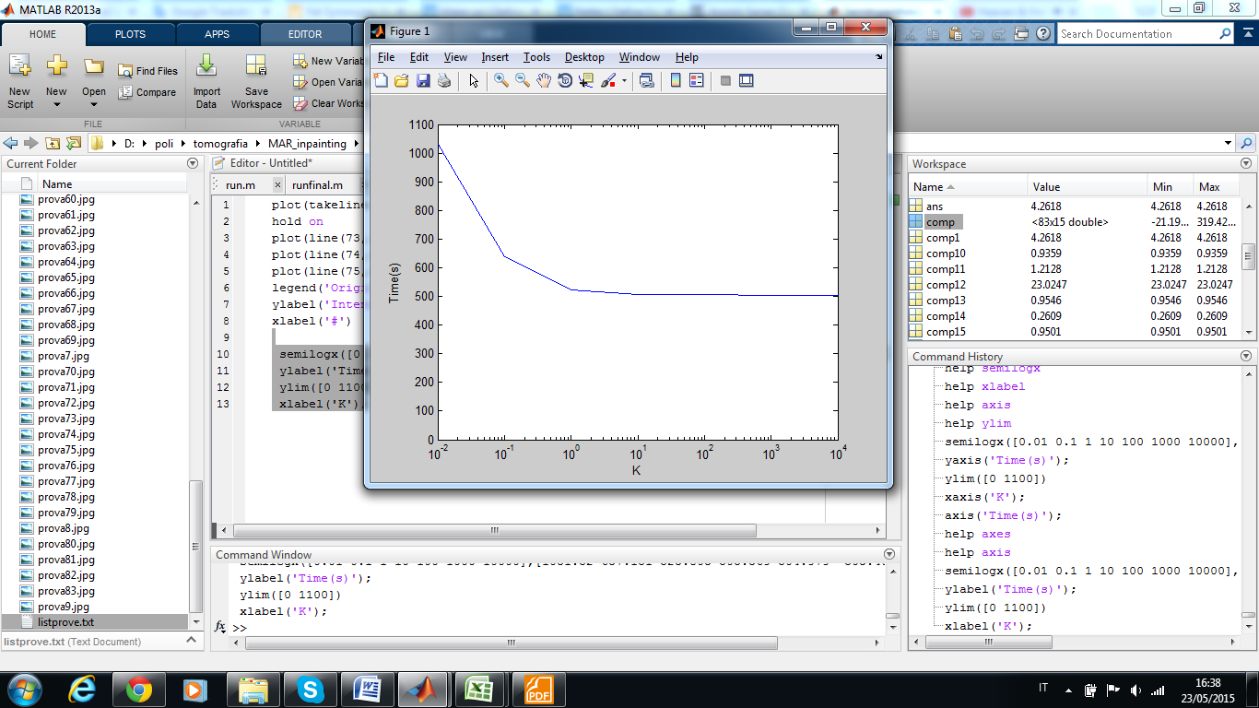

**Linear x Bertalmio**

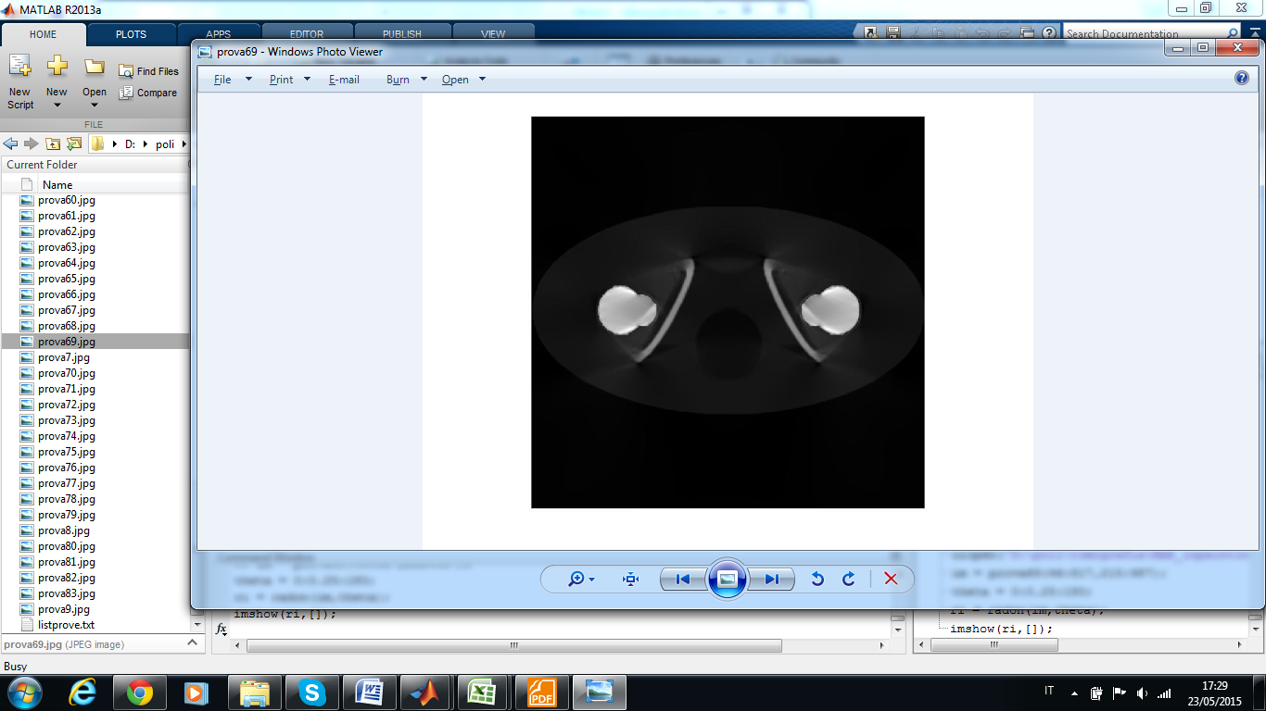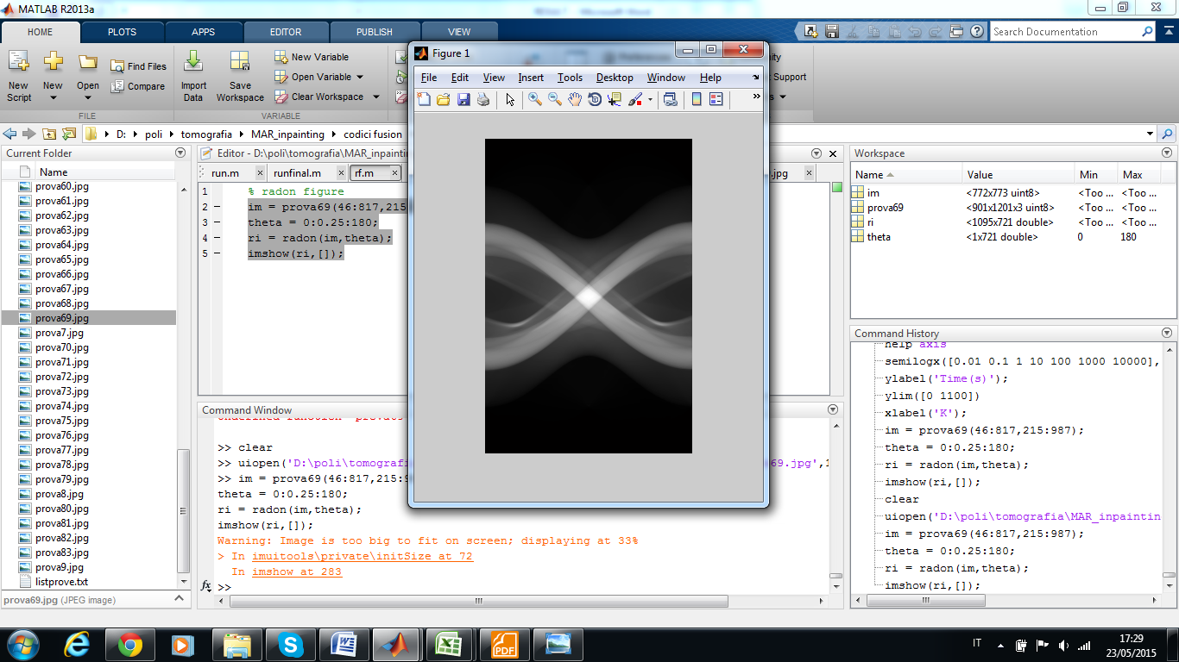 **Linear**

** Bertalmio**

|  |  |  |  |  |  |  |  |  |  |  |
| --- | --- | --- | --- | --- | --- | --- | --- | --- | --- | --- |
|  | Region 1 | | | | | Region 2 | | | | |
|  | MSE | PSNR | CC | mssim | fsim | MSE | PSNR | CC | mssim | fsim |
| Artefact | 4.262 | 17.567 | 0.920 | 0.338 | 0.974 | 1.121 | 3.349 | 0.159 | 0.000 | 0.936 |
| Linear | 6.047 | 16.047 | 0.894 | 0.381 | 0.933 | 0.065 | 15.691 | 0.979 | 0.631 | 0.981 |
| Bertalmio | 6.360 | 15.828 | 0.882 | 0.400 | 0.936 | 0.024 | 20.020 | 0.959 | 0.574 | 0.981 |

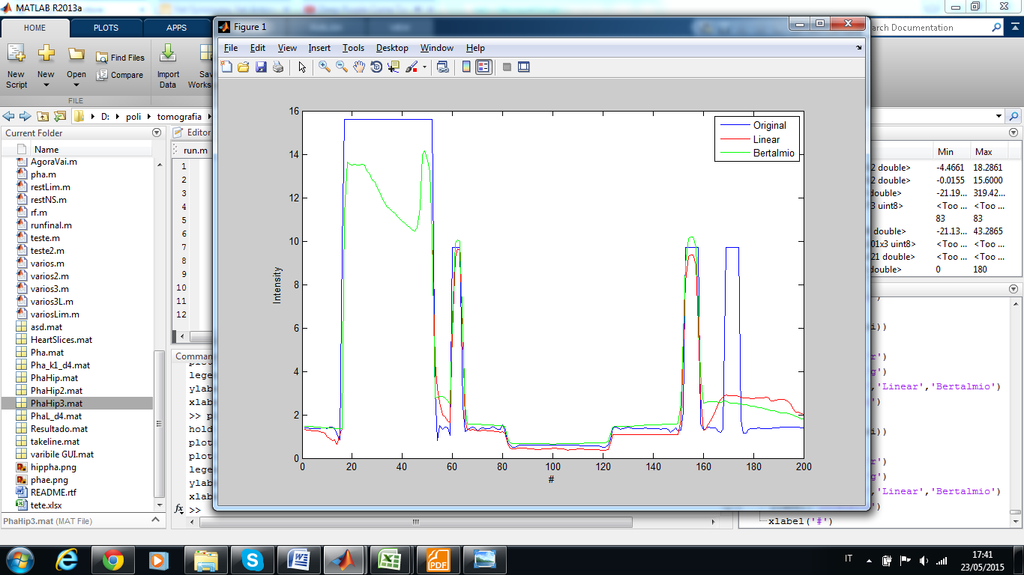

Comparing the two methods we can arrive a two conclusions: On this image, the two methods is almost equivalent, they have the same problem on the bone near to the metal implant and the remainder part is very similar to the original image. The linear method is slight better considering the the image edges ( see the pixel 60 and 160 on graph ()).

**Fusion**

The second analysis is regard to the method fusion. On this method there are two restoration process, so we will use all possible combination and compare then. The combination are Linear/Linear, Linear/Bertalmio, Bertalmio/Linear and Bertalmio, Bertalmio.

The fusion method has two parameters, n and t. We test how them change the restoration only for the case Linear/Linear, after we extrapolate the better parameters for the other cases.

**Parameter t**

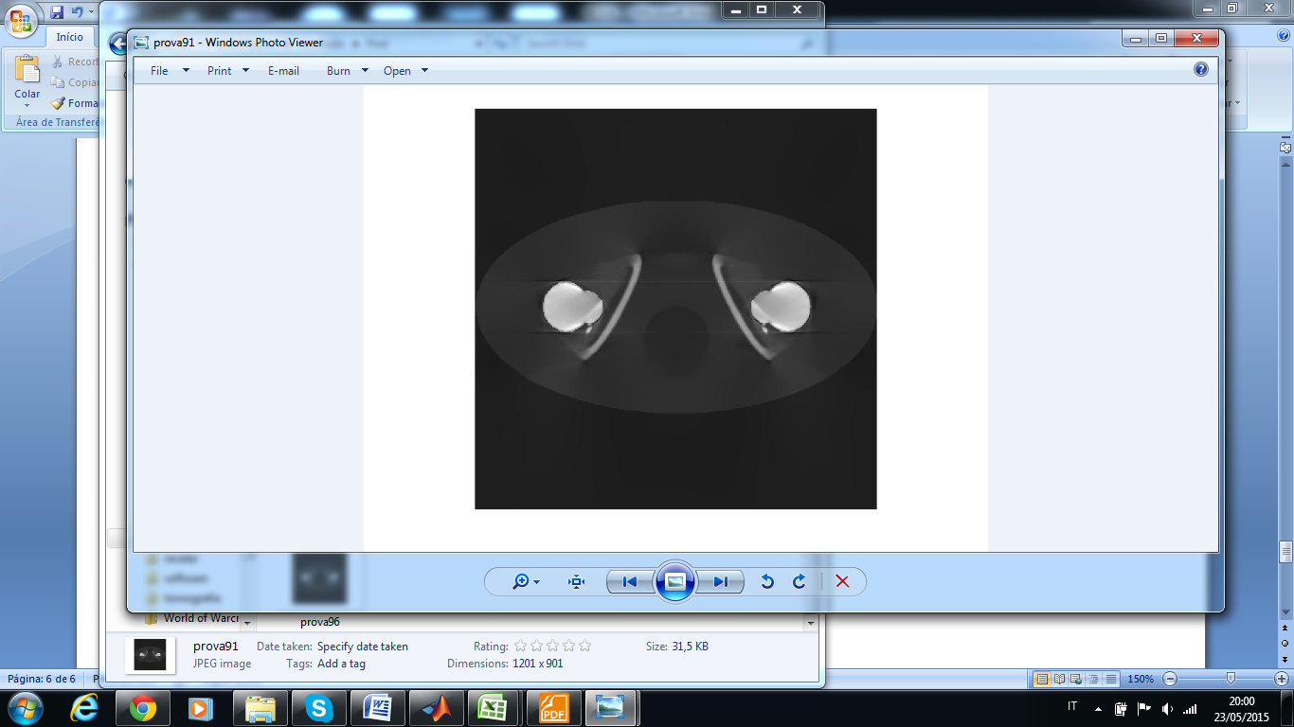 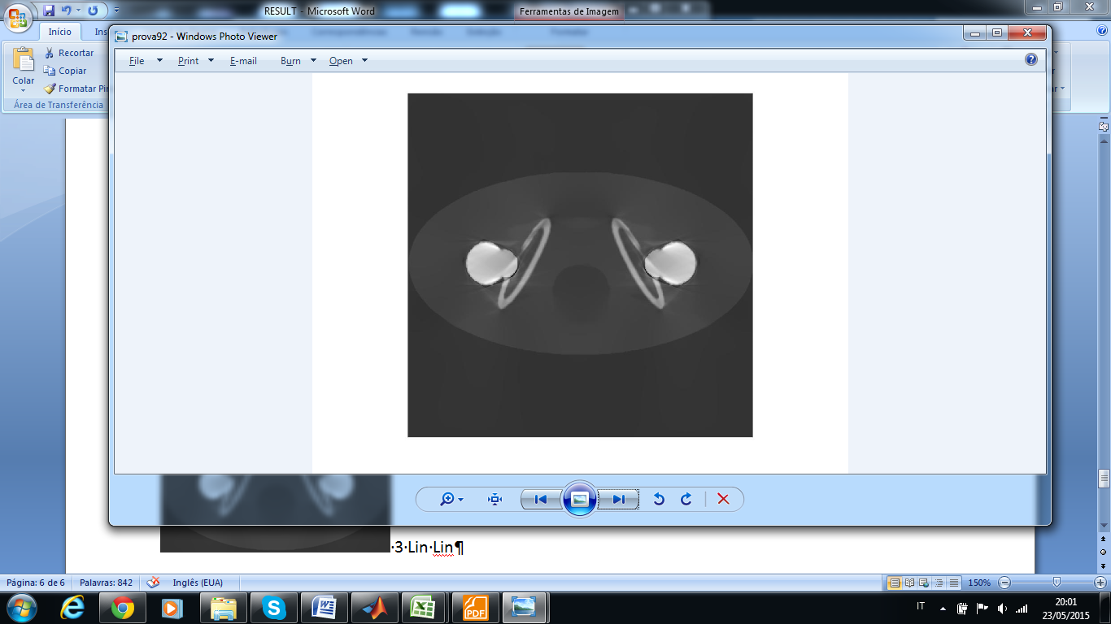 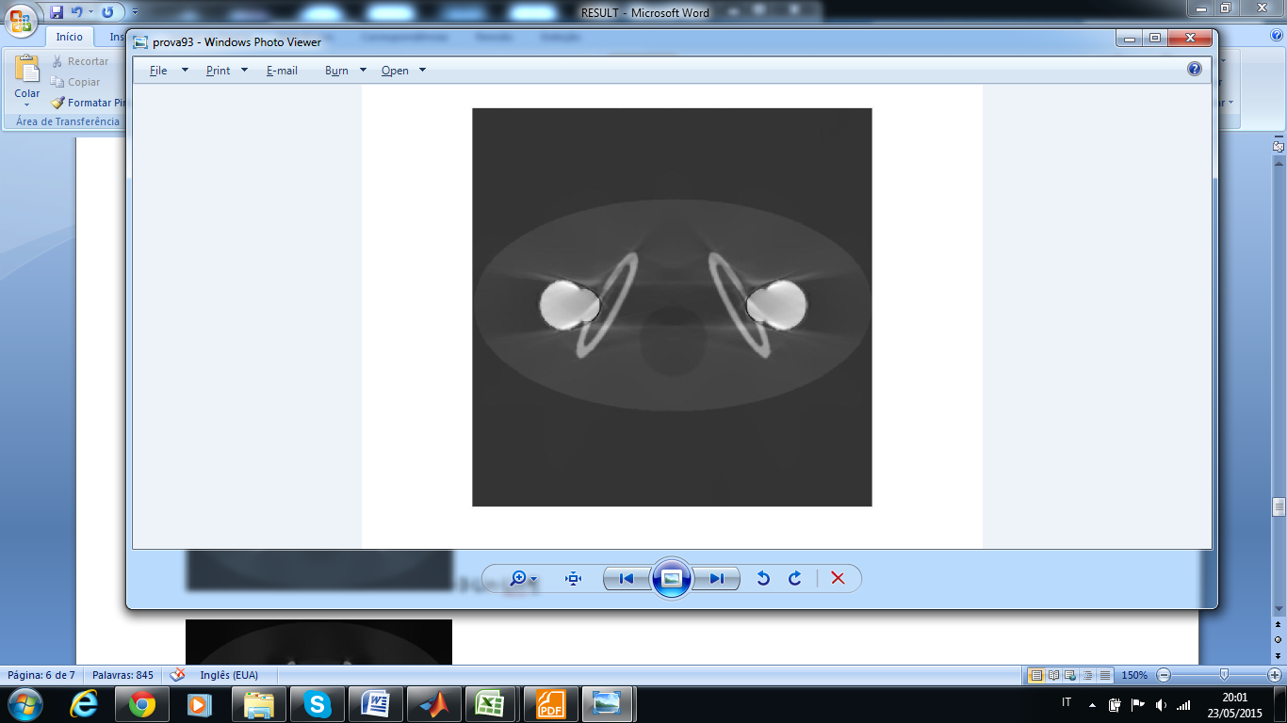

0.15 20 91 0.45 20 92 0.75 20 93

The parameter t is the most important to set accordingly, because if it's low the fusion method don't work, and if is high the artifact is not removed.

**Parameter n**

86 89 92 95

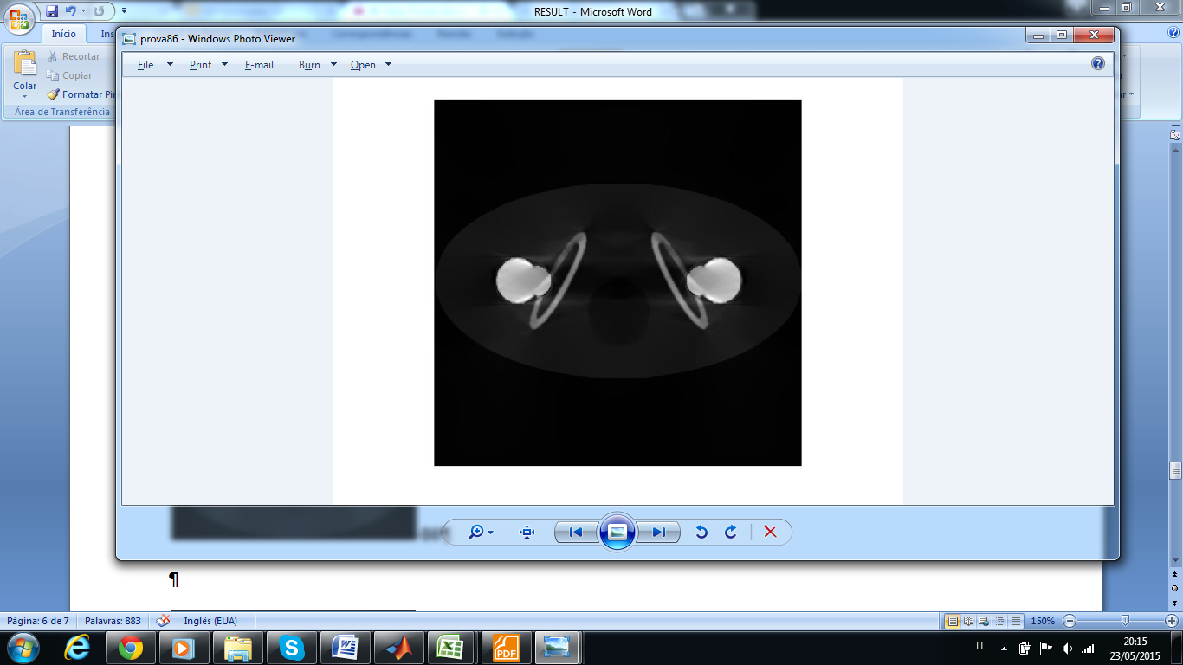 86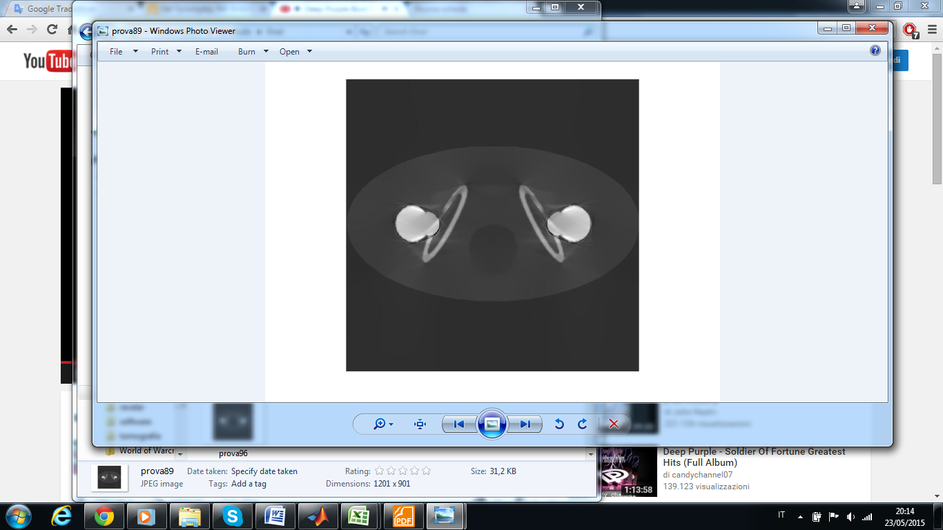89

 92 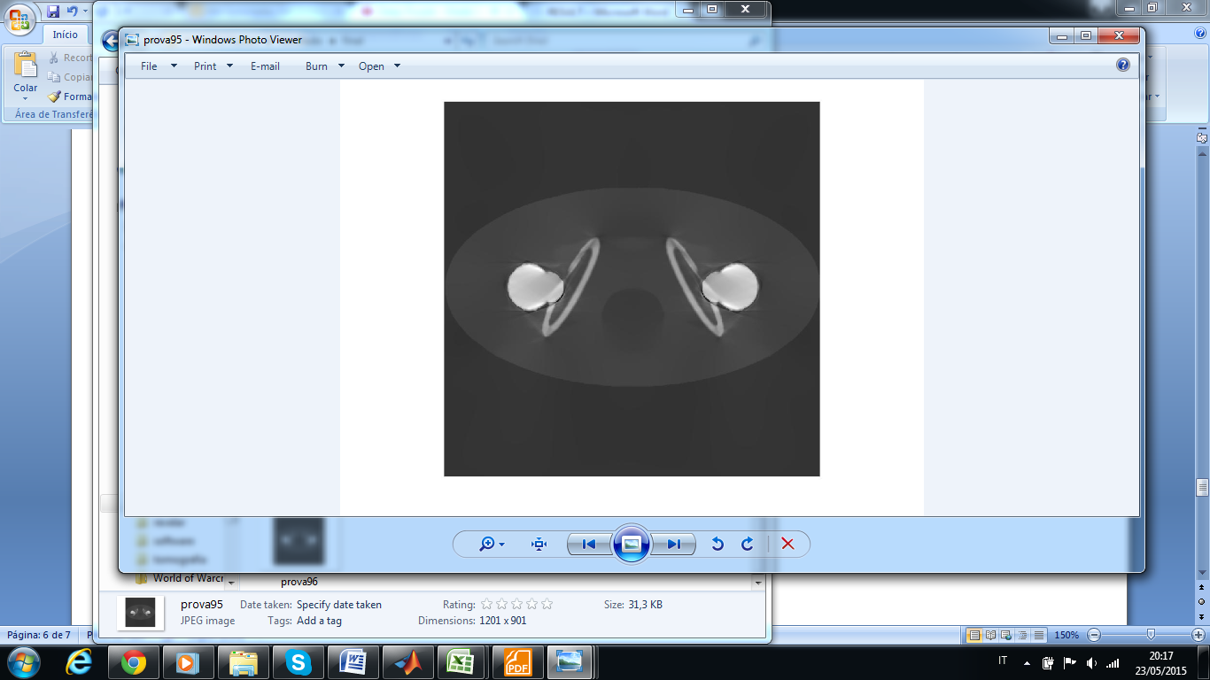95

The parameter **n** isrelevant, however is not fundamental set it to the right value. The prove show us that the best parameter depend of the region, additionally the difference are negligible , so we choose a intermediary parameter.

|  |  |  |  |  |  |  |  |  |  |  |  |  |  |  |  |
| --- | --- | --- | --- | --- | --- | --- | --- | --- | --- | --- | --- | --- | --- | --- | --- |
|  | Region 1 | | | | | Region 2 | | | | | All the image | | | | |
|  | MSE | PSNR | CC | mssim | fsim | MSE | PSNR | CC | mssim | fsim | MSE | PSNR | CC | mssim | fsim |
| Artifact | 4.262 | 17.567 | 0.920 | 0.338 | 0.974 | 1.121 | 3.349 | 0.159 | 0.000 | 0.936 | 1.213 | 23.025 | 0.955 | 0.261 | 0.950 |
| 1 | 4.382 | 17.446 | 0.930 | 0.396 | 0.965 | 0.482 | 7.017 | 0.816 | 0.135 | 0.963 | 1.099 | 23.451 | 0.964 | 0.480 | 0.975 |
| 5 | 4.426 | 17.403 | 0.924 | 0.411 | 0.964 | 0.025 | 19.879 | 0.917 | 0.418 | 0.962 | 1.092 | 23.480 | 0.963 | 0.482 | 0.974 |
| 10 | 4.307 | 17.520 | 0.926 | 0.436 | 0.965 | 0.035 | 18.456 | 0.915 | 0.418 | 0.961 | 1.072 | 23.562 | 0.964 | 0.468 | 0.973 |
| 20 | 4.380 | 17.448 | 0.924 | 0.426 | 0.964 | 0.038 | 18.103 | 0.900 | 0.388 | 0.959 | 1.085 | 23.506 | 0.963 | 0.472 | 0.973 |

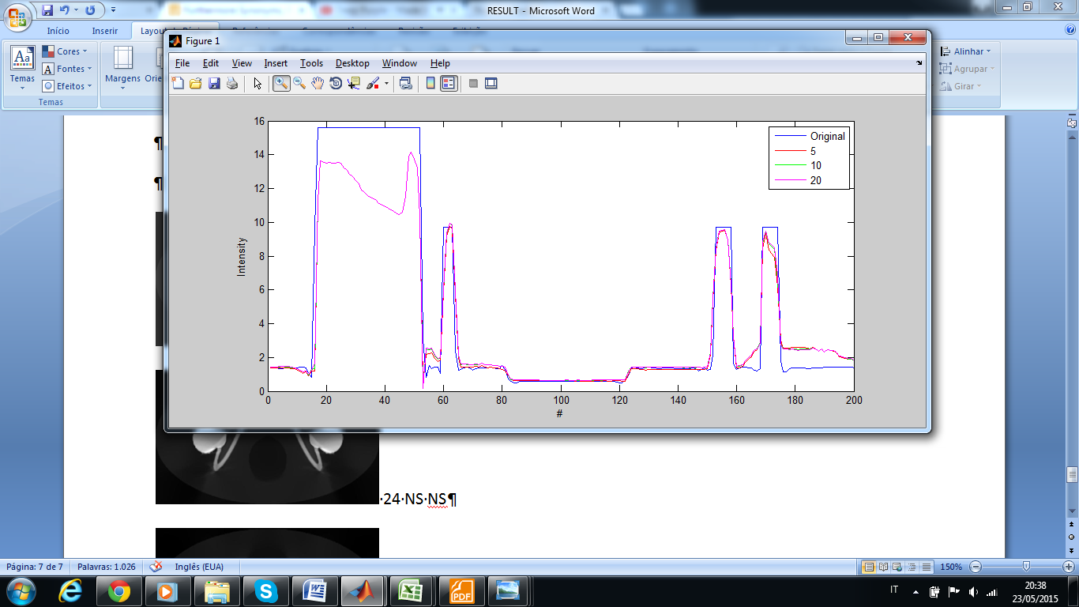

**Sub method**

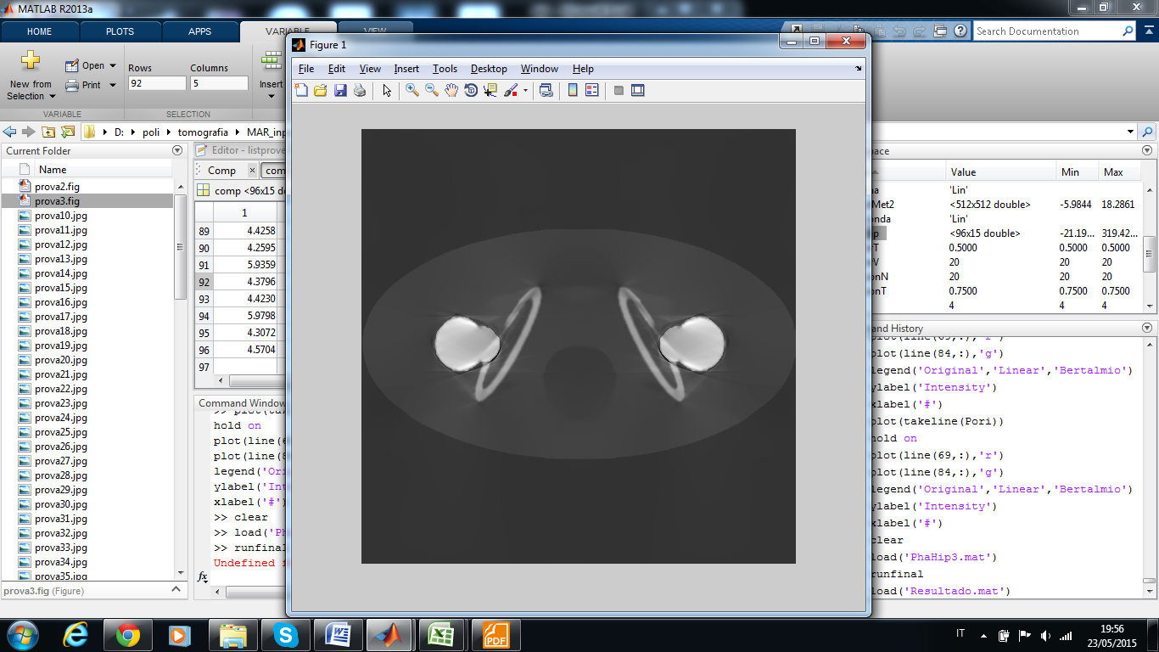 3 Lin Lin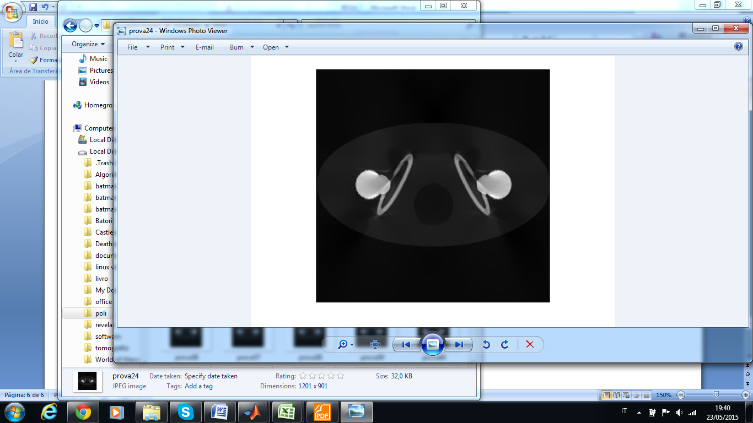24 NS NS

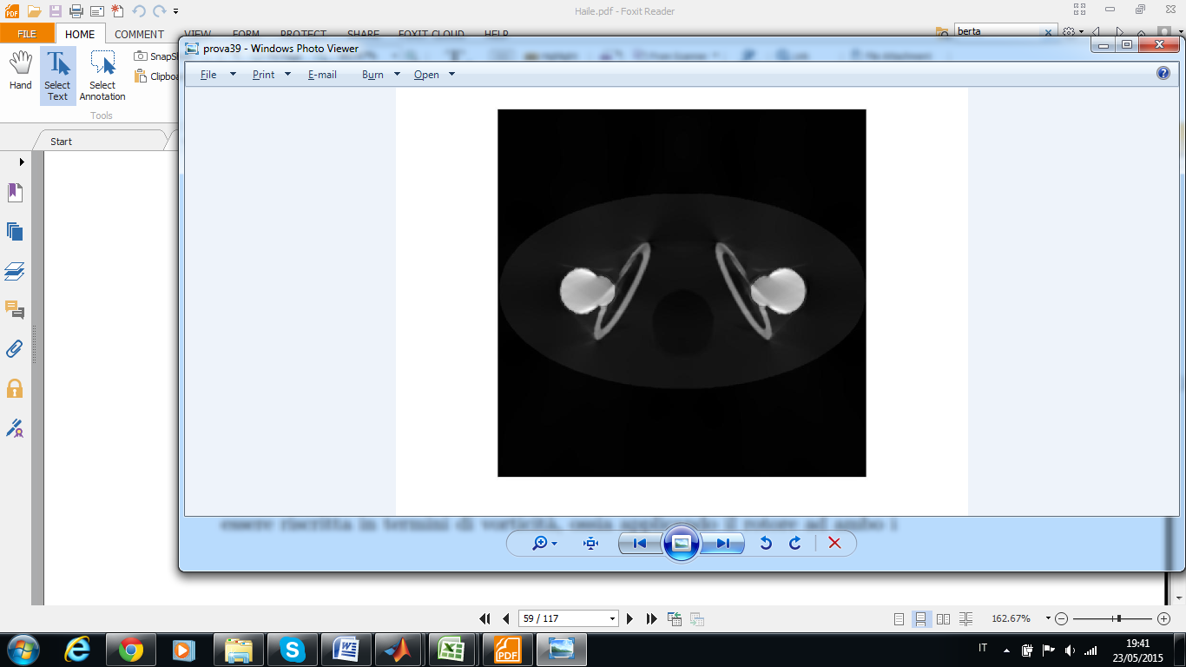 39 Lin NS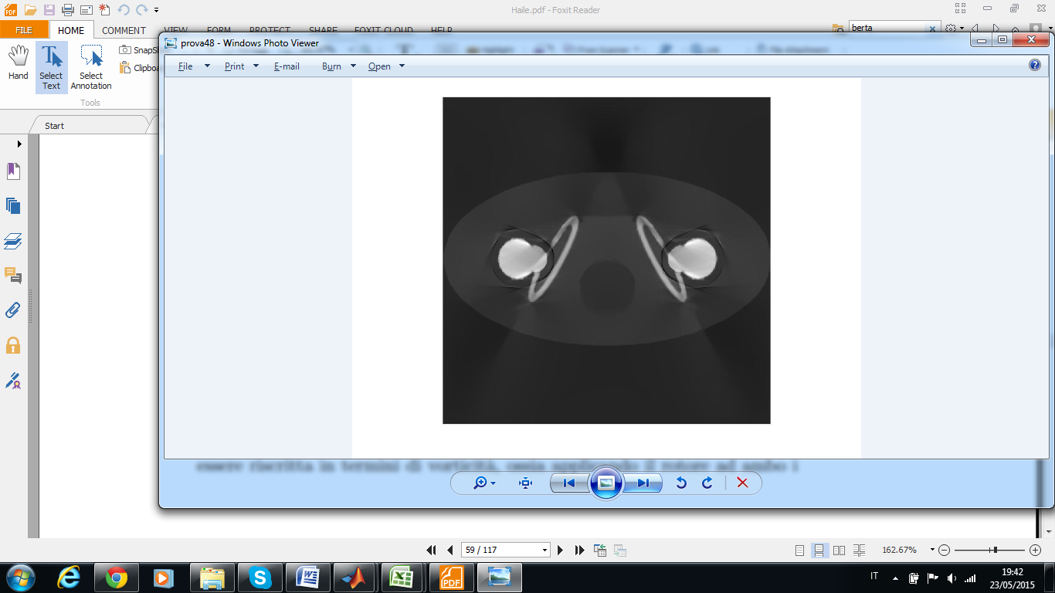48 NS Lin

Qualitatively we can disregard the combination Bertalmio/Lin due to the clear additional artifact. The combination Bertalmio/ Bertalmio isn't acceptable as well, because of the high time consummation of the method.

|  |  |  |  |  |  |  |  |  |  |  |  |  |  |  |  |
| --- | --- | --- | --- | --- | --- | --- | --- | --- | --- | --- | --- | --- | --- | --- | --- |
|  | Region 1 | | | | | Region 2 | | | | | All the image | | | | |
|  | MSE | PSNR | CC | mssim | fsim | MSE | PSNR | CC | mssim | fsim | MSE | PSNR | CC | mssim | fsim |
| Artifact | 4.262 | 17.567 | 0.920 | 0.338 | 0.974 | 1.121 | 3.349 | 0.159 | 0.000 | 0.936 | 1.213 | 23.025 | 0.955 | 0.261 | 0.950 |
| Lin/Lin | 4.380 | 17.448 | 0.924 | 0.426 | 0.964 | 0.038 | 18.103 | 0.900 | 0.388 | 0.959 | 1.085 | 23.506 | 0.963 | 0.472 | 0.973 |
| Ber/Ber | 3.866 | 17.989 | 0.935 | 0.512 | 0.970 | 0.009 | 24.236 | 0.970 | 0.643 | 0.982 | 0.988 | 23.914 | 0.968 | 0.525 | 0.974 |
| Lin/Ber | 3.768 | 18.102 | 0.943 | 0.498 | 0.969 | 0.049 | 16.925 | 0.981 | 0.681 | 0.984 | 0.954 | 24.066 | 0.971 | 0.535 | 0.971 |
| Ber/Lin | 4.315 | 17.513 | 0.918 | 0.397 | 0.962 | 0.397 | 7.861 | 0.886 | 0.272 | 0.962 | 1.137 | 23.305 | 0.958 | 0.400 | 0.969 |

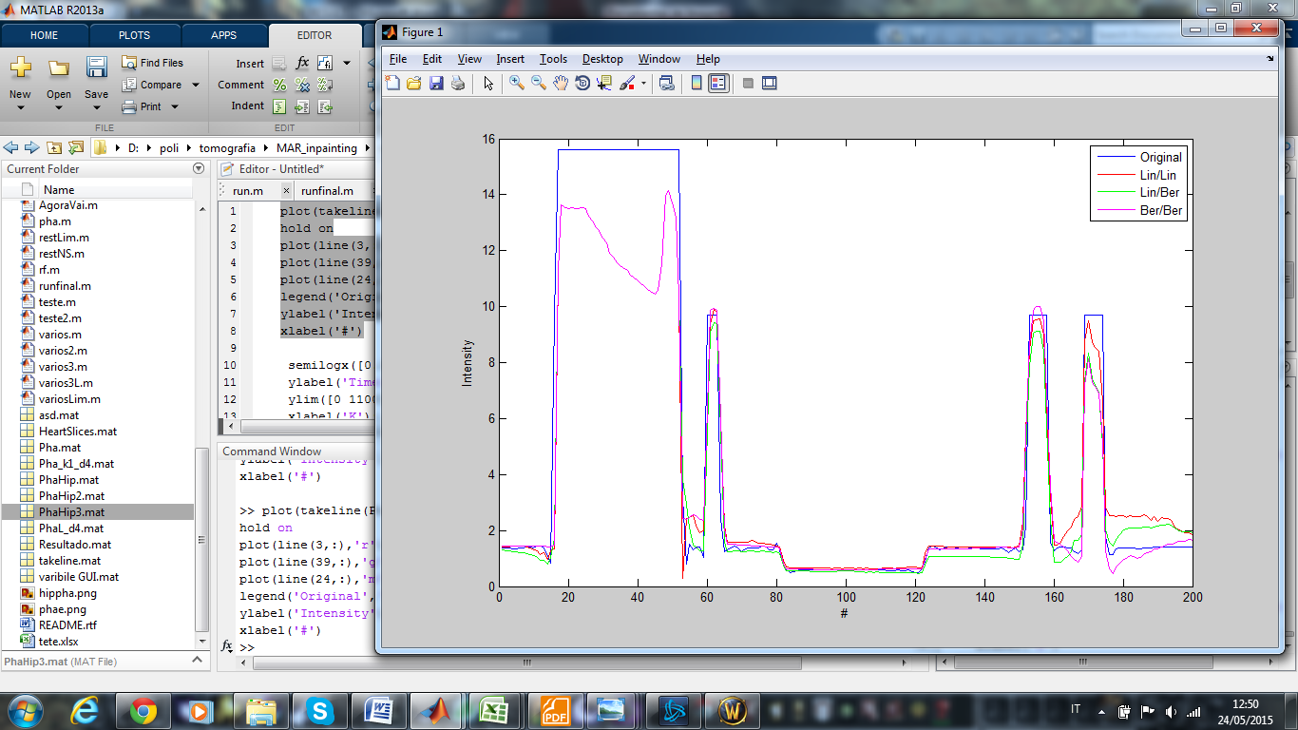

The result show us that there isn't a method that surpass the other. Depending of the regions a method is better or not. For instance, the method Lin/Ber have the lowest MSE, however between the pixel 120 and 150 the error is very high.

**CONCLUSION**

The phantom hip was a good image to test the method. Using it we arrived to two great conclusions:

The method of Bertalmio is not a good method when the inpainting domain is large. It is not surprising because if we have less information, the estimative will be corser, thus don't have much sense use a method that require more time to execute a finer estimate.

Differently, the fusion method performed very well and the goal of retrieve the loss of information was achieved. However, some artifact arise. It can be a problem or not, all depend of which part the doctor want to see to do the diagnostic.